What is an Aerotropolis?
Transportation infrastructure has always shaped the evolution and economic position of cities.
First, our major cities largely grew around seaports. Next, urban development took place along rivers that formed the backbones of the industrial revolutions in Europe and the United States.
Railroads opened up landlocked interiors of nations, fostering a third wave of city growth outward from their main terminals.
Then, the expansion of suburban roadway systems created a fourth wave of urban development.
We are now well into a fifth wave of transit-oriented development, where large commercial airports have become significant drivers of business location and urban economic growth.
In the age of Globalization, New cities known as Global cities are emerging where , airports are relocating the metropolitan center: their surrounding areas attract major concentrations of business functions previously confined to metropolitan downtowns.
History of City and Transportation and airotropolis
Christopher Choa, the award-winning urban designer and native-New Yorker, argues that in the 21st century the most successful cities will grow up around airports rather than vice-versa. Living in an "aerotropolis", we will relate to neighbours thousands of miles away. There will be winners and losers -- cities that will thrive and some that could fail.

https://www.youtube.com/watch?v=y4jmv8KKnSo

How will we live in a global city??
https://m.youtube.com/watch?v=POO_H9RII1w

In 1997 JG Ballard predicted that "the airport will be the true city of the 21st century". Now John Kasarda, an American management consultant and academic, is jetting around the world showing politicians and business leaders how Ballard's prediction is about to come true.

According to Kasarda, the future city will have "an airport at the center and concentric rings of uses radiating outward".

Kasadra aerotropolis
https://m.youtube.com/watch?v=_mu0dO64kz0

The aerotropolis is designed for the wired, always-on "Instant Age" of smart phones and smart cities, where the only law is the survival of the swiftest.
This then is the next stage in globalisation,

Frame of aerotropolis

https://m.youtube.com/watch?v=3yqQvp9P-C8

Just as cities such as Southampton or Singapore grew up around their seaports, so the airport will become the heart of tomorrow's city.

Already, over a third of the value of all world trade moves by air. This will only increase as global incomes rise and economies shift toward higher-value products that are smaller,
lighter and more compact such as microelectronics, pharmaceuticals, medical in - struments, aerospace components, and specialty perishables.
When Yunnan Airport Group attended its first Routes Asia meeting in 2008, representatives introduced the capital city Kunming and its airport, but the question they heard most from foreign delegates was, "Where is Kunming?"
Seven years later, they have their answer.
The city now has an emerging international airport in Southwest China, serves as a regional hub linking China with South Asia and Southeast Asia and is the host city of Routes Asia 2015, a gathering for aviation-related companies that want to conduct business to, from and within the region.
Over the intervening years, the Yunnan Airport Group has integrated the resources of airports across the province, improved the Kunming airport capabilities and planned new international air routes.
Dubai
https://m.youtube.com/watch?v=e6EyE3S8QK8

Songdo airport city
https://m.youtube.com/watch?v=szktRPHI1U8

Dubai
https://m.youtube.com/watch?v=srOAA914VAo

Hongkong
https://www.youtube.com/watch?v=Qylm5kptZ5c
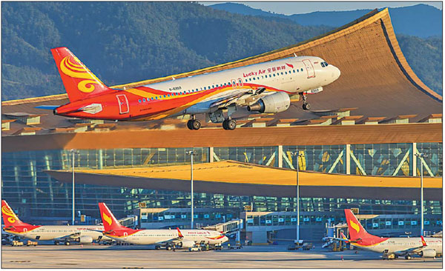

the capital city Kunming and its airport

